**Report: Tracked website Analysis for Kssprogram**

**Date:** February 29.2024

**Time:** 09:53:00

**Overview:**

The website of Kssprogram was successfully tracked using visualping monitoring tool. While the homepage initially loaded properly ,an error was detected at 09:53:00 on February 29,2024.The error was indicated a”404 – Page Not Found” status.

**Details:**

Upon initial monitoring , the homepage of kssprogram loaded without any issues, displaying the expected content and functionalities. However ,at 09/53/00 on February 29,2024, Visualping detected a significant change. The screenshot captured by the monitoring tool clearly shows the rror message indicating a “404 – Page Not Found”.

**Screenshot:**

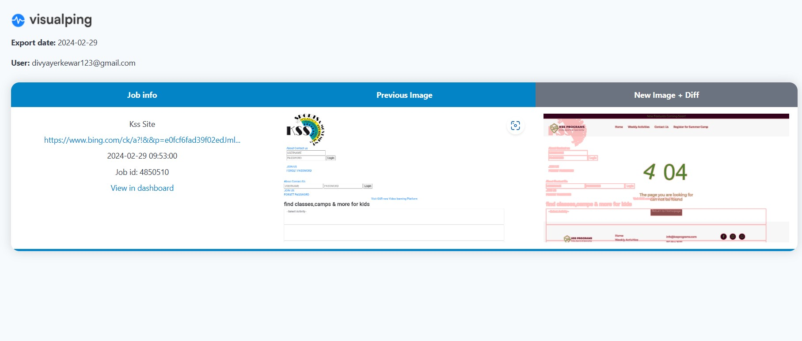

* The occurrence of a 404 error on the homepage of Kssprogram signifies potential issues with the websites navigation .Such error can negatively impact user experience , potentially driving visitors away from the site
* Investigate the cause : we should promptly investigate the cause of the 404 error. This may involve reviewing recent updates to the website
* Monitoring regularly: Regular monitoring of the websites performance and error status is essential to identify and address issues promptly. Visualping or similar monitoring tools can be utilized for continuous monitoring .

**Conclusion:**

In conclusion , the occurrence of a 404 error on the homepage of kssprogram indicates a potential issue with the websites functionality. Timely investigation ,and ongoing monitoring are necessary to ensure optimal website performance and user experience.